**ASSIGNMENT 1**

**OBJECTIVE:**

**Make a Smart Home in Tinkercad, using 2+ sensors, Led, Buzzer in single code and circuit.**

**CODE:**

**int trig=3;**

**int echo=5;**

**void setup()**

**{**

**pinMode(trig,OUTPUT);**

**pinMode(echo,INPUT);**

**pinMode(7,INPUT);**

**Serial.begin(9600);**

**pinMode(10,OUTPUT);**

**pinMode(4,OUTPUT);**

**pinMode(12,OUTPUT);**

**}**

**void loop()**

**{**

**double a=analogRead(A2);**

**Serial.print("adc value:");**

**Serial.println(a);**

**double v=a/1024;**

**double tvolt=v*5;**

**Serial.print("temp volt:");**

**Serial.println(tvolt);**

**double o=tvolt-0.5;**

**double t=o*100;**

**Serial.print("temp is:");**

**Serial.println(t);**

**digitalWrite(trig,LOW);**

**digitalWrite(trig,HIGH);**

**delayMicroseconds(10);**

**digitalWrite(trig,LOW);**

**float dur=pulseIn(echo,HIGH);**

**float dist=(dur*0.0343)/5;**

**Serial.println("distance:");**

**Serial.println(dist);**

**int m=digitalRead(7);**

**Serial.print("motion detected : ");**

**Serial.println(m);**

**if(t>=60)**

**{**

**Serial.println("high temperature");**

**digitalWrite(10,HIGH);**

**}**

**else**

**{**

**Serial.println("low temperature");**

**digitalWrite(10,LOW);**

**}**

**if(dist<=20)**

**{**

**Serial.println("door open");**

**digitalWrite(4,HIGH);**

**}**

**else**

**{**

**Serial.println("door close");**

**digitalWrite(4,LOW);**

**}**

**if(m==1)**

**{**

**Serial.println("on the light");**

**digitalWrite(12,HIGH);**

**delay(50);**

**}**

**else**

**{**

**Serial.println("off the light");**

**digitalWrite(12,LOW);**

**}**

**delay(50);**

**}**

**Output:**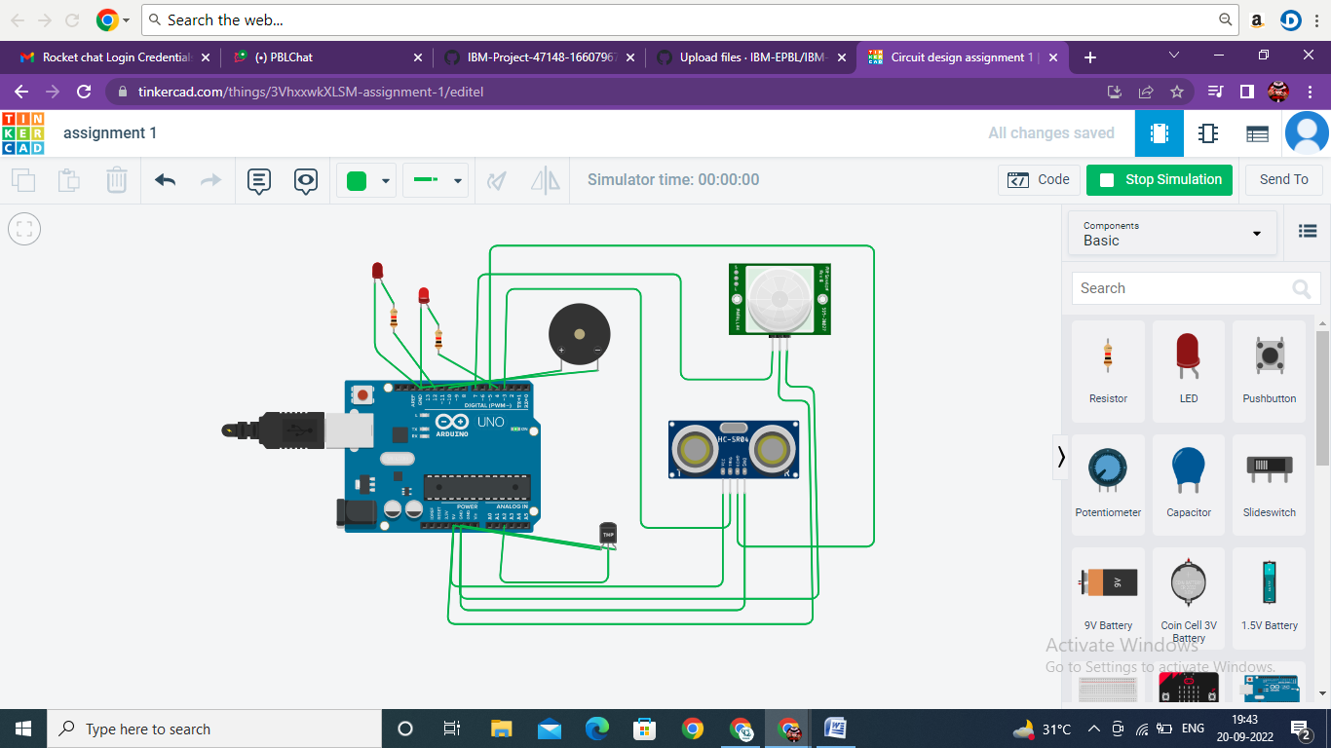

**SIMULATION LINK: https://www.tinkercad.com/things/3VhxxwkXLSM-assignment-1/editel**